Live Well Arizona

Identifying, connecting and integrating efforts to improve well-being and health statewide – within a broader contextual framework.
Health Is More Than Health Care. Live Well Arizona starts from the recognition that significant opportunities for improving well-being and health are found not just in health care, but everywhere we live, work, learn and play.
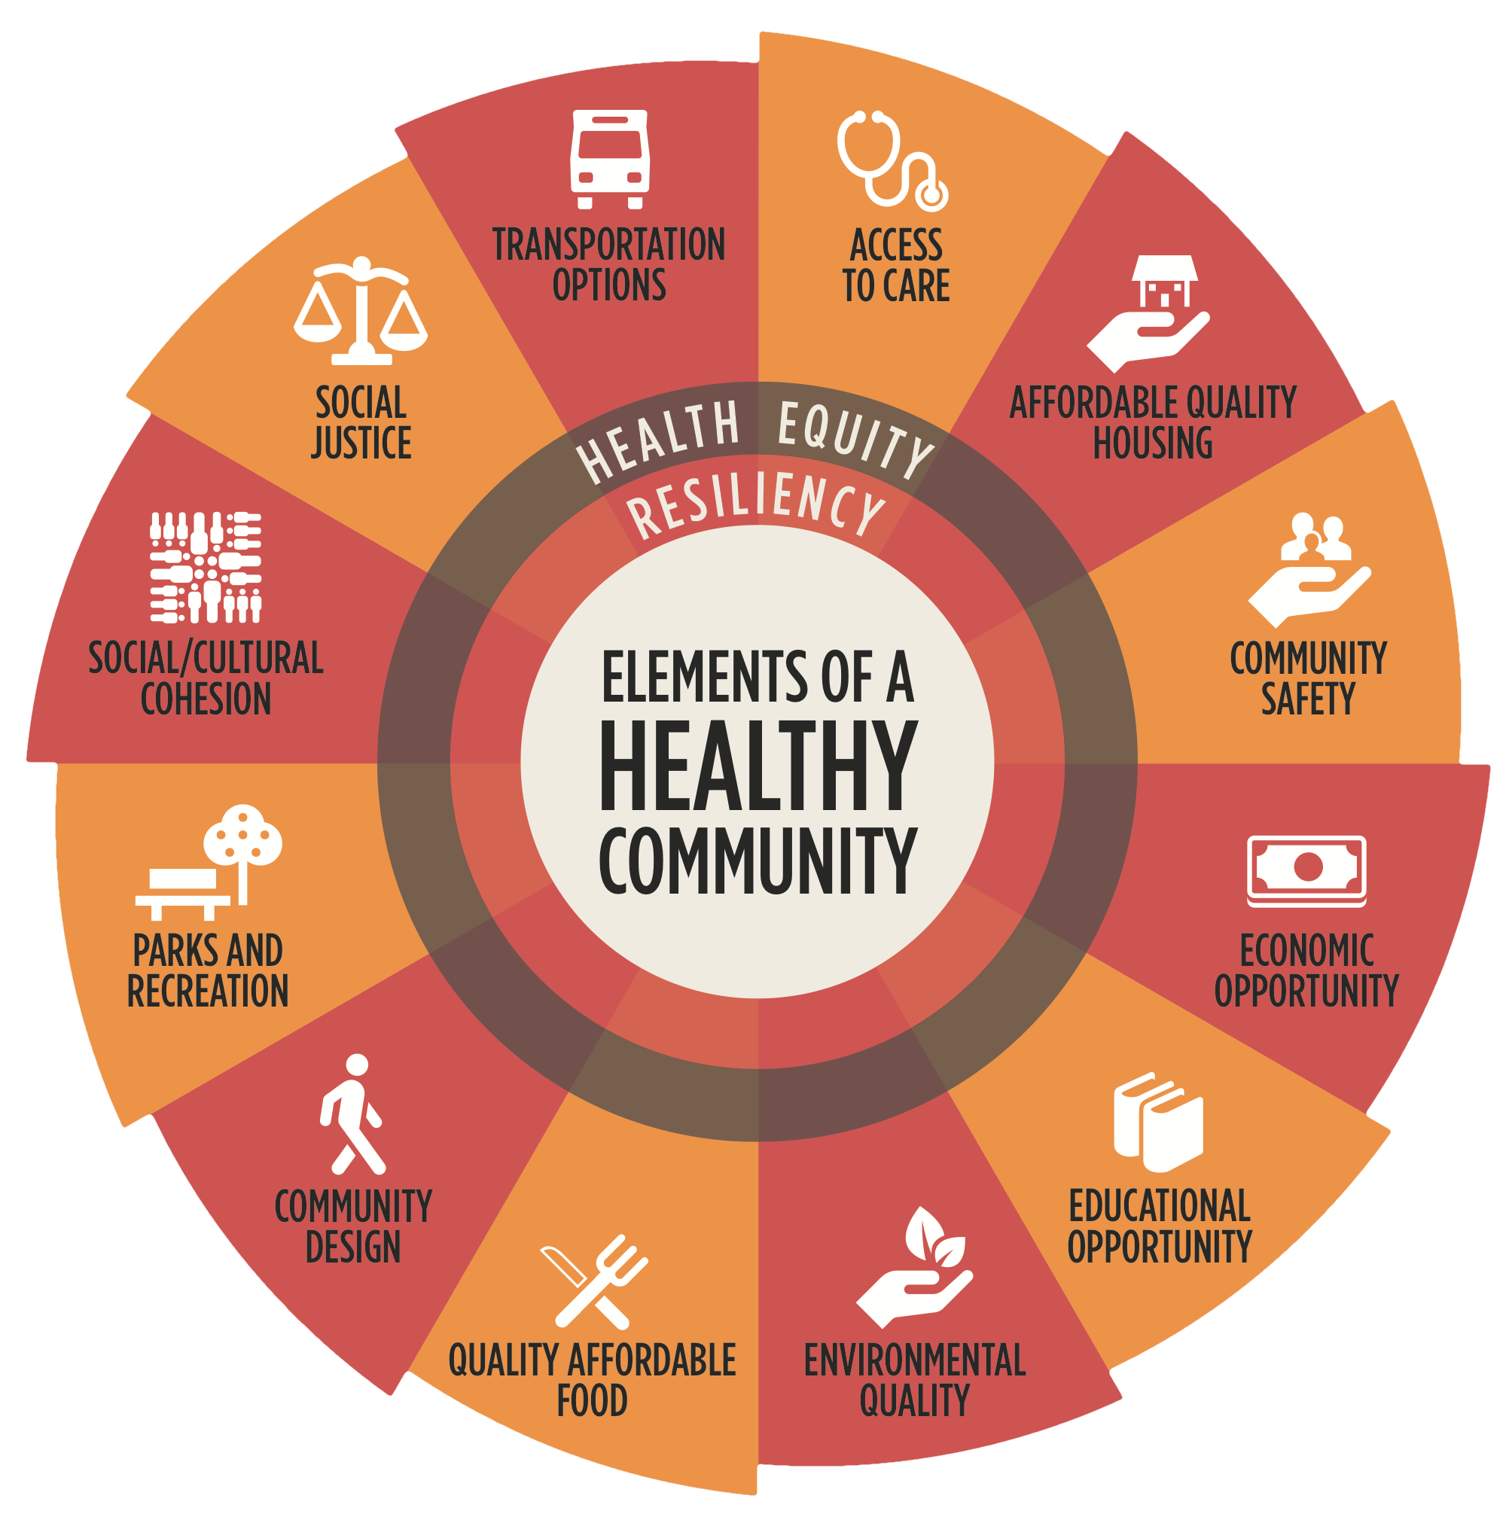
Informed by the work of the World Health Organization and the Centers for Disease Control and Prevention, Vitalyst and community partners developed the Elements of Healthy Community wheel in 2016 to identify and demonstrate the interrelated nature of 14 community factors that impact health. Via conferences, meetings and workshops, Vitalyst is directly engaging councils of government, universities, counties, cities, towns, business, nonprofits, associations, chambers of commerce and other stakeholders.
Our Goals:
- Identify, lift up and celebrate efforts to help Arizonans be healthier and live well.
- Facilitate connections between groups and sectors.
- Shift the health paradigm – health is more than health care.
- Influence policies and systems for change.
What We’re Doing. Vitalyst is connecting with as many stakeholder groups as possible, facilitating workshops to engage participants in shifting the health paradigm and developing next steps toward improving well-being and health in their communities. At the livewellaz.org website we are curating pages for the Elements of a Healthy Community – with each element page designed to provide visitors quick access to top national experts, key Arizona resources, projects already underway, and a short list of successful national projects that could be happening here soon. In 2017, Vitalyst built upon a successful year of webinars and launched the Vitalyst Spark podcast with episodes that tell the stories behind the work of creating healthy communities.
Where We’re Heading. The feedback is clear: stakeholders and communities are interested in continuing this dialogue and approach for the long haul – and Vitalyst will be there to help. Through the website, podcast, convenings, workshops and methods we will develop together with all interested parties, Vitalyst will continue the momentum started by the 2017 Year of Healthy Communities, remaining focused on our overall goal of shifting the health paradigm to produce policies, systems and environmental changes that support an overarching vision enabling all Arizonans to Live Well.
Connect, and Learn More. Visit livewellaz.org

